**Make a Chernoff Face**

**Instructions:** Draw a Chernoff Face by answering the following questions. Below your face write a short statement about why you chose to attend this session today. Once you’re done share your drawing with a neighbor.

Left eye: How often you work with data

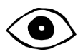

never



A few times a year

Half of my time is spent on this

This is my primary responsibility

Right eye: How often you visualize data



1 year or less

2-5 years

10+ years

6-9 years

Hair: number of years as a librarian



Breakfast

Lunch

Dinner

Nose: Favorite meal



Drama

Action

Sci-Fi

Comedy

Horror

Romance

Mouth: Favorite movie genre

Herman Chernoff, an applied mathematician and statistician invented Chernoff faces in 1973 to display multivariate data. The human eye easily recognizes faces and notices small differences. Mapping variables to facial characteristics must be done carefully so that the variable’s perceived importance is not misleading.

**Visualization Evaluation**

**Instructions:** Work with a neighbor and discuss three changes you’d make to each visualization.

**Visualization 1 Visualization 2**

**Visualization 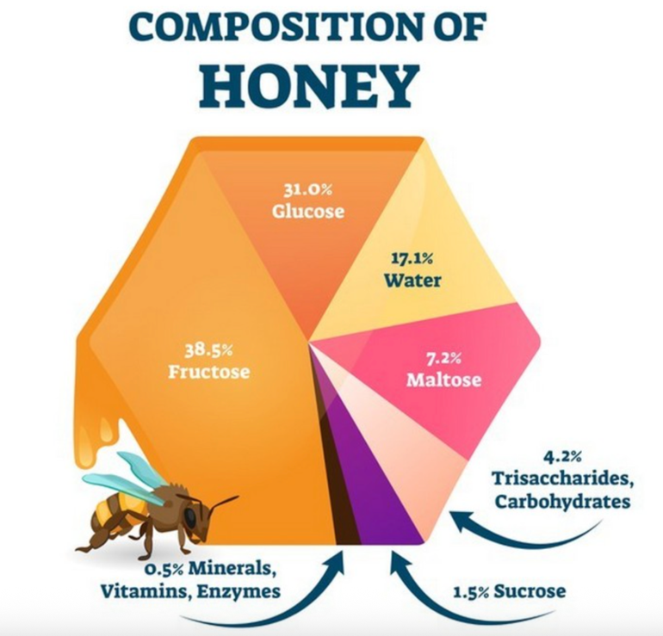3**